**HEX locations for Original Tecmo Bowl 32 Team ROM with Updated Graphics**

* **631f to 639d**– Coin flip team names (3 letter abbreviation). **Team order is same as TABLE 1A below.**

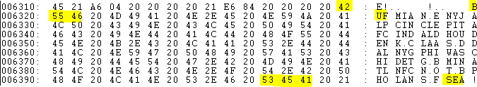

* **69b8** **to** **72b5** – Team names depicted above rosters on opening screen crawl (3 letter abbreviation). **Team order is same as TABLE 1A below.**

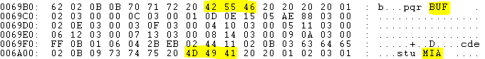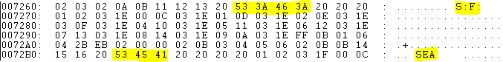

* **74f9 to 7716**– Team names depicted on team select screen (When entering this into Hex they are listed from left to right then back to left to right etc. I.e. - BUF, DAL, MIA, NYG, NE, PHI, NYJ, WAS etc. See below)

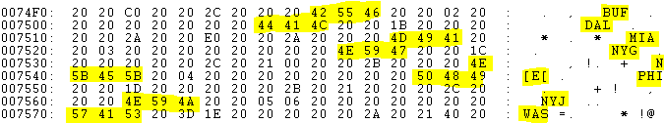

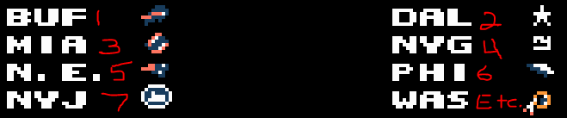

* **a6eb** **to a769**– Team Playbook names (3 letter abbreviation) **Team order is same as TABLE 1A below.**

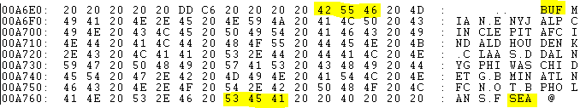

**TABLE 1A**

|  |  |
| --- | --- |
| 1. BUF | 17. DAL |
| 1. MIA | 18. NYG |
| 1. N.E. | 19. PHI |
| 1. NYJ | 20. WAS |
| 1. BAL | 21. CHI |
| 1. CIN | 22. DET |
| 1. CLE | 23. G.B. |
| 1. PIT | 24. MIN |
| 1. HOU | 25. ATL |
| 1. IND | 26. CAR |
| 1. JAK | 27. N.O. |
| 1. TEN | 28. T.B. |
| 1. DEN | 29. ARI |
| 1. K.C. | 30. LAR |
| 1. OAK | 31. S.F. |
| 1. S.D. | 32. SEA |

* **a776** starts the HEX code for the tiles that make up the Team names displayed when you score a Touchdown (i.e. BUFFALO !). The letters are input in halves. The top part of the letters and exclamation point are entered first then the bottom halves of the letters and exclamation point are entered second. See example below.
* Starting at **a7be** 74 75 60 61 04 05 74 75 60 61 are the top halves of the letters in the word MIAMI. Each byte is ¼ of a letter. 74 75 is the top half of the letter “M”, 60 61 is the top half of the letter “I” etc. 09 is the top half of the exclamation point. Starting at **a7e1** 76 77 62 63 0A 0B 76 77 62 63 make up the bottom half of the word MIAMI. 5B is the bottom half of the exclamation point.

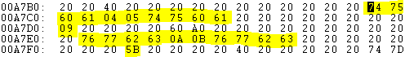



* When entering these tiles for the letters a quick reference:
  + Notice the 40 20 highlighted. All tiles start after the 40 20.
  + You can fit a team name up to 14 letters (28 bytes)
  + The 09 highlighted is the top of the exclamation point
  + The 60 A0 is just like the 40 20 for the upper part of the letters. You can fit a team name with 14 letters (28 bytes) after the 60 A0.
  + The 5B highlighted is the bottom of the exclamation point.
  + Be sure to start your team names the same number of bytes away from 40 20 on top as 60 A0 on the bottom so the letters match up.
  + All of the 20’s you see (minus the 40 20 highlighted) are blank areas.
  + The snippet below with the highlights is BUFFALO and MIAMI. See if you can differentiate how the tiles are laid out from the Hex code.

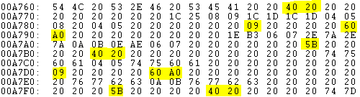

Below is a map for all of the Letters for the team names.

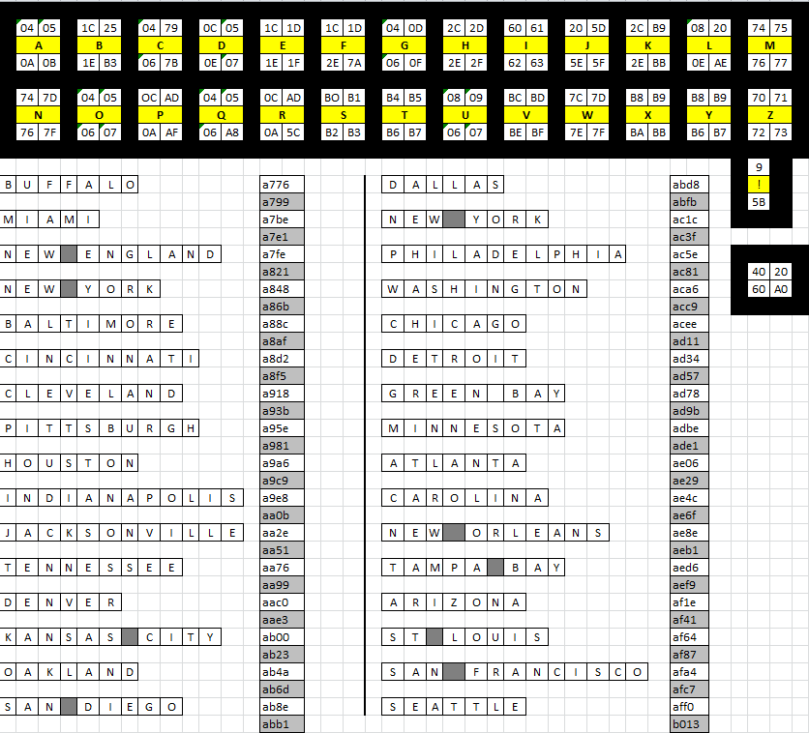

* **b030 to b220** – After game news report team jersey colors. (Only modify the highlighted Bytes (2,3,6,7 & 11 for each team. As you can see below, bytes 2 & 3 match bytes 6 & 7. Byte 11 matches Bytes 3 & 7. **Teams order is same as TABLE 1A above**.)

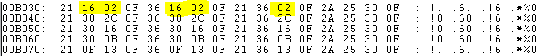

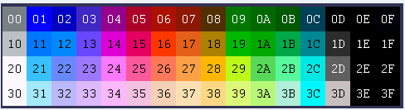

* **b234** starts the HEX code for the tiles that make up the Team names displayed on the news report at the end of the game. Same rules apply as with the tiles for the letters above. The only differences are:
  + 02 is blank instead of 20.
  + There is no exclamation point.
  + The Team letters on the top start after 21 23 1A and can only be up to 12 letters long (24 bytes)
  + The Team letters on the bottom start after 21 43 9A and can only be up to 12 letters long (24 bytes)
  + **Again be sure to line up your hex code for the tiles in the same place on both top and bottom or your letter will not line up.**

The snippet below is of SANFRANCISCO and SEATTLE. The 28 29 08 09 24 25 after the first highlighted 21 23 1A is the upper half of “SAN” in SANFRANCISCO. The 2A 2B 06 07 26 27 following the first highlighted 21 43 9A is the bottom half of “SAN” in SANFRANCISCO.

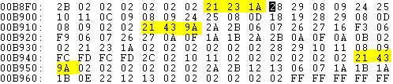

Below is a map for the letter tiles for the after game news report.

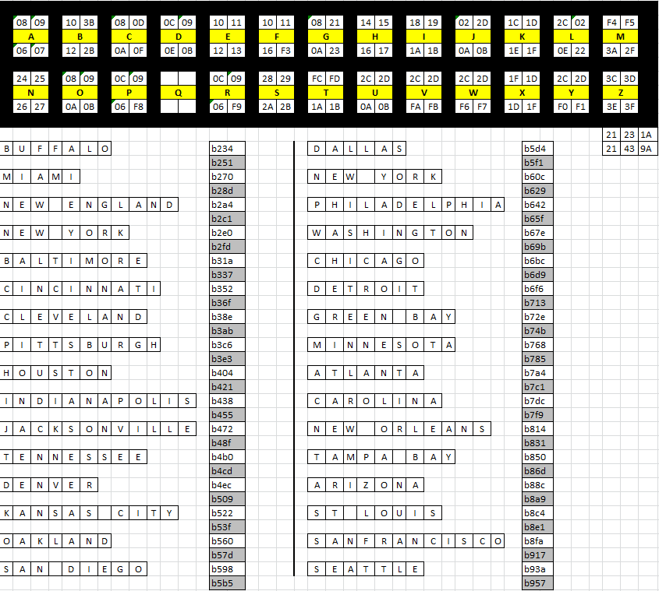

* **e868** – Buffalo Player attributes start here. The player order is like this (IF Offense & Defense lined up left side on screen):

***ENTER YOUR ATTRIBUTES FOR THE SAME PLAYERS IN THE SAME ORDER AS YOU ENTER THE NAMES STARTING AT 202b2 & 24051 OTHERWISE THE ATTIRBUTES WON’T MATCH UP TO THE PLAYERS.***

|  |  |  |  |
| --- | --- | --- | --- |
| **Single back Set or Two Back Set** | | **3-4 Defense or 4-3 Defense** | |
| 1.Top WR | 1. TE | 13. Top DE | 13. Top DE |
| 2. TE | 2. Top RB | 14. NT | 14. MLB |
| 3. RB | 3. Bottom RB | 15. Bottom DE | 15. Bottom DE |
| 4. QB | 4. QB | 16. TOLB | 16. TOLB |
| 5. Bottom WR | 5. Bottom WR | 17. TILB | 17. Top DT |
| 6. LG | 6. LG | 18. BILB | 18. Bottom DT |
| 7. C | 7. C | 19. BOLB | 19. BOLB |
| 8. RG/RT | 8. RG/RT | 20. Top DB | 20. Top DB |
| 9. LT | 9. LT | 21. Bottom DB | 21. Bottom DB |
| 10. KR | 10. KR |  |  |
| 11. K | 11. K |  |  |
| 12. P | 12. P |  |  |

Here is where each teams Player attributes start:

|  |  |  |  |  |  |  |  |
| --- | --- | --- | --- | --- | --- | --- | --- |
| **BUF** | **e868** | **HOU** | **eb68** | **DAL** | **ee68** | **ATL** | **f168** |
| **MIA** | **e8c8** | **IND** | **ebc8** | **NYG** | **eec8** | **CAR** | **f1c8** |
| **N.E.** | **e928** | **JAK** | **ec28** | **PHI** | **ef28** | **N.O.** | **f228** |
| **NYJ** | **e988** | **TEN** | **ec88** | **WAS** | **ef88** | **T.B.** | **f288** |
| **BAL** | **e9e8** | **DEN** | **ece8** | **CHI** | **efe8** | **ARI** | **f2e8** |
| **CIN** | **ea48** | **K.C.** | **ed48** | **DET** | **f048** | **LAR** | **f348** |
| **CLE** | **eaa8** | **OAK** | **eda8** | **G.B.** | **f0a8** | **S.F.** | **f3a8** |
| **PIT** | **eb08** | **S.D.** | **ee08** | **MIN** | **f108** | **SEA** | **f408** |

* **Final Attribute ends on** **F45b**

ROMS are hexadecimal based. That means that they are base 16 instead of base 10. The range is from 0-F. 0-9= 0-9. A=10, B=11, C=12, D=13, E=14, F=15, 10=16, 11=17, 1F=31, etc... See example below for Bo Jackson.

**Bo Jackson 43 0B 50 8A**  
  
**Bit 1:**4 -> Acceleration time (Rushing Power) - The larger the number, the more time it takes for the player to get to max speed.

**Bit 2:**3 -> Initial speed (Running Speed) - This is the speed you run at while you are accelerating to max speed. For offensive players this number varies from 0-4. For defensive players, it varies from 0-3.  
  
**Bit 3 and 4:** 0B -> Max speed - The speed at which players top out at after accelerating from their initial speed. Offensive players vary from 05 to 0B while defensive players vary from 0C to 0F.   
  
**Bit 5 and 6:** 50 -> Hitting Power - The higher the hitting power, the more likely you are to win grapples or "popcorn" the other player (A 32 point difference will create "popcorn" i.e 56HP defender and 88HP Kevin Mack or 48HP defender and 80HP Herschel Walker or Bo Jackson)

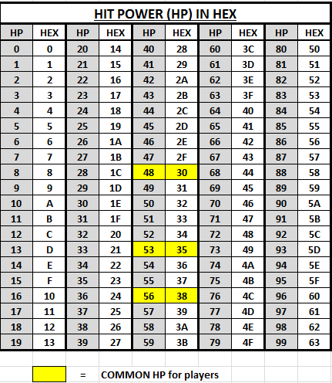  
  
**Bit 7:** 8 -> Race - Tecmo has it's basic black or white player setting. 0 is used for white and 8 is used for black. Any value from 0-7 is white or any value from 8-F is black. (Washington uses a different color "black" than the other teams due to their dark red uniform color)  
  
**Bit 8:** A -> Special Ability -  
Quarter Backs: All QBs have the value 8 here.  
  
RBs, WRs, TE: This value controls the QB passing speed/pitching speed plus it possibly might control the receiving ability. The numbers vary from 8-E here while most players on the same team have the same values.  
  
Kickers and Punters - These probably control either the max distance the ball travels or the speed of the kick meter, but I honestly didn't care enough to figure it out. Kickers vary from 5 - A while Punters vary from 6 to E.  
  
Kick Returners and Defensive players - These players all have a value of 0 which means that they don't use this bit. Changing it also seems to have no affect.

* **10350** – Don’t touch
* **10360** – Home Jersey colors start here (Example Below. The teams follow the same pattern as the title crawl screen. Only adjust Bytes 2,4,6,8 & 11.)
* **10560** – Away Jersey colors start here (Example Below. The teams follow the same pattern as the title crawl screen. Only adjust Bytes 2,4,6,8 & 11.)

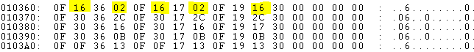

The place to edit team uniform colors begins at address 10360. That line is for Buffalo. Miami begins at 10370, New England at 10380, etc. **See TABLE 1A above for team order.**

Buffalo’s line breaks down like this:  
0F 16 36 02 0F 16 17 02 0F 19 16 30 00 00 00 00

The first four bytes are four white players. The second four are for black players. The third four are for the field. The green numbers are for the team's helmets & pants. The blue numbers are for the team's jerseys. The red numbers are for the players' skin color. 36 is used for all white players. Black players have 17, 05, or 0F depending on the team. The violet numbers are for the team's end zone. This is generally just a variation on one of the uniform colors, but not exactly the same, or else players would partially disappear. The other numbers are constant for all teams. 0F is black, the first two times this appears in each team line does not seem to affect anything. The third 0F is for the black parts of the field. The 19 is green, the color of the field. The 30 is the white part of the field.



* **12550** – Home jerseys for end zone celebrations start here
* **12750** – Away jerseys for end zone celebrations start here

**See TABLE 1A above for Team order**

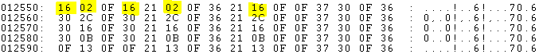



Another place you might want to edit is the data for the touchdown screen, where the players jump & high-five each other. This begins at address 12550 and each team has one line, beginning with Buffalo. Their line looks like this:  
16 02 0F 16 21 02 0F 36 21 11

The green numbers are again for the players' helmets. The first two blue numbers are for the players' jerseys. The third occurrence seems to be one of the colors in the background crowd. All the other numbers are constant for all teams.



* **18010** - Playbooks start here. (**Not play art**) Buffalo is first, followed by Miami etc. **Refer to TABLE 1A above for Team order** .Depicted below are 8 plays 4 for Buffalo and 4 for Miami. Buffalo’s being run from the I set (02 before each play) and Miami being run from the offset I (03 before each play) and Shotgun (05 before the play)

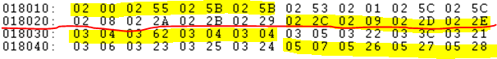

|  |  |  |  |  |  |  |  |
| --- | --- | --- | --- | --- | --- | --- | --- |
| **BUF** | **18010** | **HOU** | **18110** | **DAL** | **18210** | **ATL** | **18310** |
| **MIA** | **18030** | **IND** | **18130** | **NYG** | **18230** | **CAR** | **18330** |
| **N.E.** | **18050** | **JAK** | **18150** | **PHI** | **18250** | **N.O.** | **18350** |
| **NYJ** | **18070** | **TEN** | **18170** | **WAS** | **18270** | **T.B.** | **18370** |
| **BAL** | **18090** | **DEN** | **18190** | **CHI** | **18290** | **ARI** | **18390** |
| **CIN** | **180b0** | **K.C.** | **181b0** | **DET** | **182b0** | **LAR** | **183b0** |
| **CLE** | **180d0** | **OAK** | **181d0** | **G.B.** | **182d0** | **S.F.** | **183d0** |
| **PIT** | **180f0** | **S.D.** | **181f0** | **MIN** | **182f0** | **SEA** | **183f0** |

**Here are the original plays from the original game.**

Plug them into the current ROM for the same plays. Remember you still have to change the play art.

**Indianapolis**

Play 1: 02 00, 02 55, 02 5B, 02 5B

Play 2: 02 53, 02 01, 02 5C, 02 5C

Play 3: 02 02, 02 1A, 02 1C, 02 1B

Play 4: 02 0F, 02 03, 02 1D, 02 1F

------------------------------------------------

**Miami**

0304 0362 0304 0304

0305 0322 033C 0321

0306 0323 0325 0324

0507 0526 0527 0528

-------------------------------------------------

**Cleveland**

0200 0255 025B 025B

0253 0201 025C 025C

0208 022A 022B 0229

022C 0209 022D 022E

-------------------------------------------------

**Denver**

030A 0357 0360 0360

0355 0300 035B 035B

0303 032F 031F 031D

0531 050B 0532 0533

-------------------------------------------------

**Seattle**

030A 0357 0360 0360

0355 0300 035B 035B

0303 032F 031F 031D

0336 030C 0337 0338

-------------------------------------------------

**LA**

040D 0458 0461 0461

040E 040E 040E 040E

0463 041E 043B 0420

0439 0410 043A 043B

---------------------------------------------------

**Wash**

0200 0255 025B 025B

0211 0211 0211 0211

0205 023D 0222 0221

023E 0213 023F 0240

---------------------------------------------------

**SF**

035B 035B 035B 035B

0303 031F 031D 0334

0308 0329 032B 032A

0512 0541 0542 0543

---------------------------------------------------

**Dal**

0314 0354 035D 035D

0359 0315 035F 035F

0306 0344 0325 0345

0546 0516 0547 0548

---------------------------------------------------

**NY**

0314 0354 035D 035D

0359 0315 035F 035F

0305 033C 0322 0321

032C 0309 032D 032E

---------------------------------------------------

**Chi**

030A 0357 0360 0360

0359 0315 035F 035F

0317 0349 034B 034A

034C 0318 034D 034E

----------------------------------------------------

**Min**

020A 0257 0260 0260

0219 0219 0219 0219

0213 024F 0240 023F

022A 0208 0229 022B

* **1a172 to 1a191** - Defenses: **00= 3-4** and **01= 4-3.** (Buffalo, Miami, New England, New York etc.) **Refer to TABLE 1A above for team order.**



* **1a192 –** Defensive blitz bytes start here. When you change offensive plays around you have to change the corresponding blitz bytes for the play in both the 3-4 (depicted by 06) and the 4-3 (depicted by 07) defenses. Below the first two plays’ blitz bytes are highlighted for both the 3-4 and 4-3).

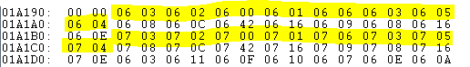

**Here are the blitz bytes for the original offense plays. These must be changed to match the offensive plays. For 4-3 defenses the number are the same but instead of 06 to start each play 07 is used.**

i.e: if you use IND run 1, CHI Run 2, SEA Pass 1, and WAS Pass 2 then your blitz bytes would look like this:

|  |  |
| --- | --- |
| **Vs 3-4** | |
| 06 03 06 02 06 00 06 01 | 06 35 06 03 06 34 06 33 |
| 06 07 06 09 06 0e 06 0a | 06 0c 06 1a 06 13 06 0e |
| **Vs 4-3** | |
| 07 03 07 02 07 00 07 01 | 07 35 07 03 07 34 07 33 |
| 07 07 07 09 07 0e 07 0a | 07 0c 07 1a 07 13 07 0e |

**VS IND**

06 03 06 02 06 00 06 01

06 06 06 03 06 05 06 04

06 08 06 14 06 0B 06 0D

06 09 06 07 06 0A 06 0E

--------------------------------------------

**VS MIA**

06 03 06 11 06 0F 06 10

06 07 06 0E 06 0A 06 14

06 12 06 0C 06 0E 06 13

06 08 06 30 06 15 06 2F

--------------------------------------------

**VS CLE**

06 03 06 02 06 00 06 01

06 06 06 03 06 05 06 04

06 08 06 0C 06 42 06 16

06 09 06 08 06 16 06 0E

-------------------------------------------

**VS DEN**

06 03 06 19 06 17 06 18

06 02 06 03 06 01 06 00

06 07 06 09 06 0E 06 0A

06 1C 06 08 06 1D 06 2F

---------------------------------------------

**VS SEA**

06 03 06 19 06 17 06 18

06 02 06 03 06 01 06 00

06 07 06 09 06 0E 06 0A

06 14 06 08 06 13 06 0E

---------------------------------------------

**VS LA**

06 03 06 21 06 1F 06 20

06 25 06 03 06 24 06 23

06 08 06 40 06 3D 06 41

06 3E 06 08 06 3F 06 3D

-----------------------------------------------

**VS WAS**

06 03 06 02 06 00 06 01

06 2E 06 03 06 2D 06 2C

06 07 06 09 06 0E 06 16

06 0C 06 1A 06 13 06 0E

----------------------------------------------

**VS SF**

06 03 06 02 06 00 06 01

06 07 06 0E 06 0A 06 14

06 12 06 14 06 42 06 0A

06 08 06 31 06 32 06 2F

----------------------------------------------

**VS DAL**

06 03 06 06 06 04 06 05

06 35 06 03 06 34 06 33

06 12 06 0C 06 0E 06 13

06 32 06 08 06 36 06 2F

----------------------------------------------

**VS NY**

06 03 06 06 06 04 06 05

06 35 06 03 06 34 06 33

06 07 06 0C 06 0E 06 16

06 09 06 08 06 14 06 0E

----------------------------------------------

**VS CHI**

06 03 06 19 06 17 06 18

06 35 06 03 06 34 06 33

06 08 06 14 06 3B 06 2B

06 14 06 08 06 09 06 0E

-----------------------------------------------

**VS MIN**

06 03 06 19 06 17 06 18

06 3A 06 03 06 39 06 38

06 1A 06 0C 06 0E 06 13

06 0C 06 12 06 16 06 42

* **1b800** is the line where you add the hex code in red below to fix the Pat Beach play located in the INDY playbook. By entering this, the TE will now be covered on the play instead of always being open.

**1b800: 21 06 28 11 01 00 00 00 1f fb 00 00 00 00 00 00**

* **20246 & 20247** – If you want to change **94 & 95** to **aa & ab** to remove the TKL stat shown below the players name and replace it with the INT stat. (Doing early ROM’s it is hard to find a tackle total for each player. All players have an INT stat even if it is zero. Also when doing this you must change the defensive players position to 03. (You will only have to do this for the Defensive backs - 04) . Example below.

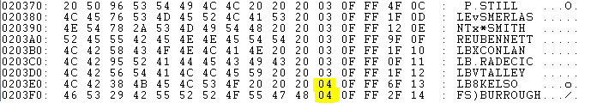

* **202b2 –** Start of player names and stats.

As depicted below:

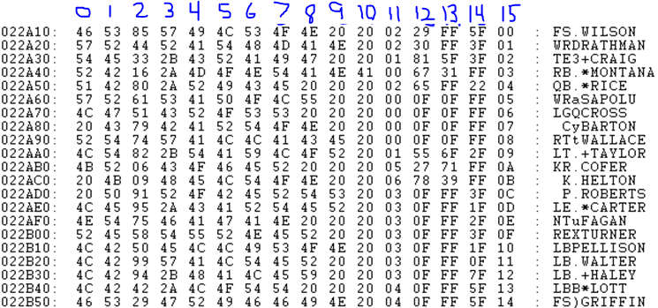

1. First letter of position played. This is a carryover from the player above this line. Can be clicked on to the far right and typed in



1. Second letter of position played. This is a carryover from the player above this line. Can be clicked on to the far right and typed in



1. Click on the byte in column 2 (0,1,**2**) to type the number of the player otherwise you need to know the ascii code to type it in the far right.



1. 3-10 These are used to type in the player’s name. Can be clicked on to the far right and typed in. If an asterisk (*) is typed in front of players name a red star will appear before the player’s name on the game field. If a plus (+) is typed in front of a player’s name a white star will appear in front of the player’s name. I have used these in the past to denote ALL PRO (*) or PRO BOWL (+)players. The number 20 is used a blank.



1. This depicts the players position and what type of stats are shown. **00**=QB or Offensive Line. **01**=RB or Kick Returner. **02**=Receiver or Tight End. **03**=Defensive line or Linebacker **04**=Defensive back. **05**=Kicker. **06**=Punter.

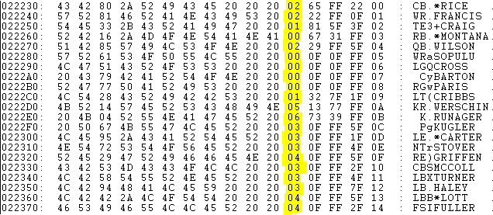

1. For receivers the number of receptions goes here. If a Receiver has 100 or more catches then the first two numbers will go here. For Running backs the first two numbers of how many yards they rushed for goes here. For Quarterbacks the Completion percentage goes here. Offensive linemen get 0F put here. Kick Returners are the same as running backs. Kickers put the number of field goals made here. Punters put the number of punts here. Defensive Players put INT, or TKL here depending on what you did with **20246 & 20247.**

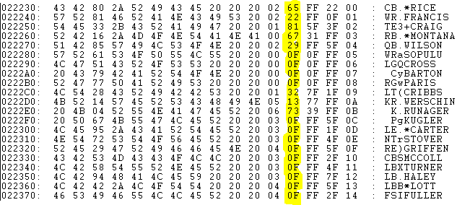

1. Receivers put the third number followed by F here if they had 100 or more catches (i.e 103 catches would be 10 in column 12 and 3F in column 13. Running backs put either put their third number followed by and F or third and fourth numbers of their 1000 yard statistic. Quarterbacks put the number of TD’s thrown. O linemen put 0F. Kick returners do the same as running backs. Kickers put their FG %. Punters put their punting Average. Defensive linemen, Linebackers and Defensive backs put FF.

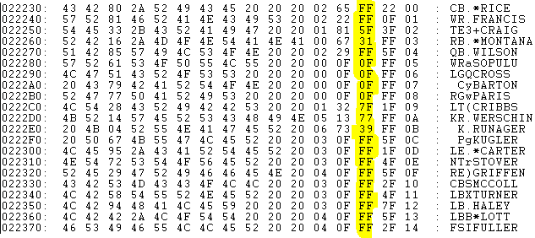

1. Receivers put the number of TD’s. If single digit it should be followed by F. Running backs same as receivers. QB’s FF. O-Linemen FF. Kick returners same as running backs. Kickers and Punters FF. D-Linemen number of sacks. If single digits put F after the number. Defensive backs put their average here??? **NOTE: if you have changed** **20246 & 20247** **from** **94 & 95** to **aa & ab then All defensive personnel will have to show 03 in column 11. Interceptions will be entered as opposed to TKL in column 12 and Sacks entered in Column 14.**

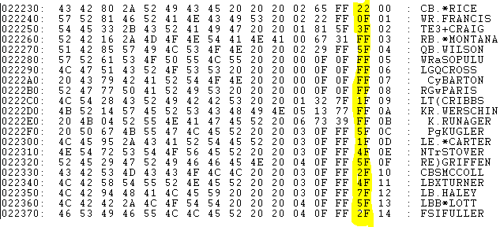

1. Column 15 is not to be touched.

* **24051** - Start of the player names as they will be shown during Interceptions, Touchdowns, and at the conclusion of the Tecmo Bowl. I suggest you keep them in the same order as the team was input in the player stats portion under **202b2. ALWAYS leave a 20 in column 0 and in column 15. Use 5b in the byte section for a period (.) Use a bracket ([) in the section to the right where the names appear for the same result.**
* **See line 26910 for an example of J.L. Williams and again at 26990 for B.J. Edmonds**
* **See line 26960 to show to leave a 20 (blank) at both the start and end of a name.**
* **Try to make an even amount of blanks to the left and right of the entire name. When an odd number of blanks occur I usually start further to the left and leave the extra space to the right. I.e. 26970 Bryan Millard has one blank (20) to the left and two to the right.**

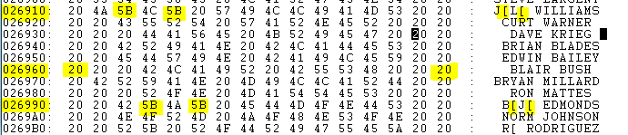

* **I have an editor from Tecmo Turd. I can’t get it to work like he designed, but it will change the plays, play art (important) and all of the offensive and defensive play and blitz bytes for you. Definitely a life saver in that department.**

**Hope this is helpful. Any questions contact me anytime.**